SQL Assignment-1

1. Write a query to get a Product list (id, name, unit price) where current products cost less than $20.

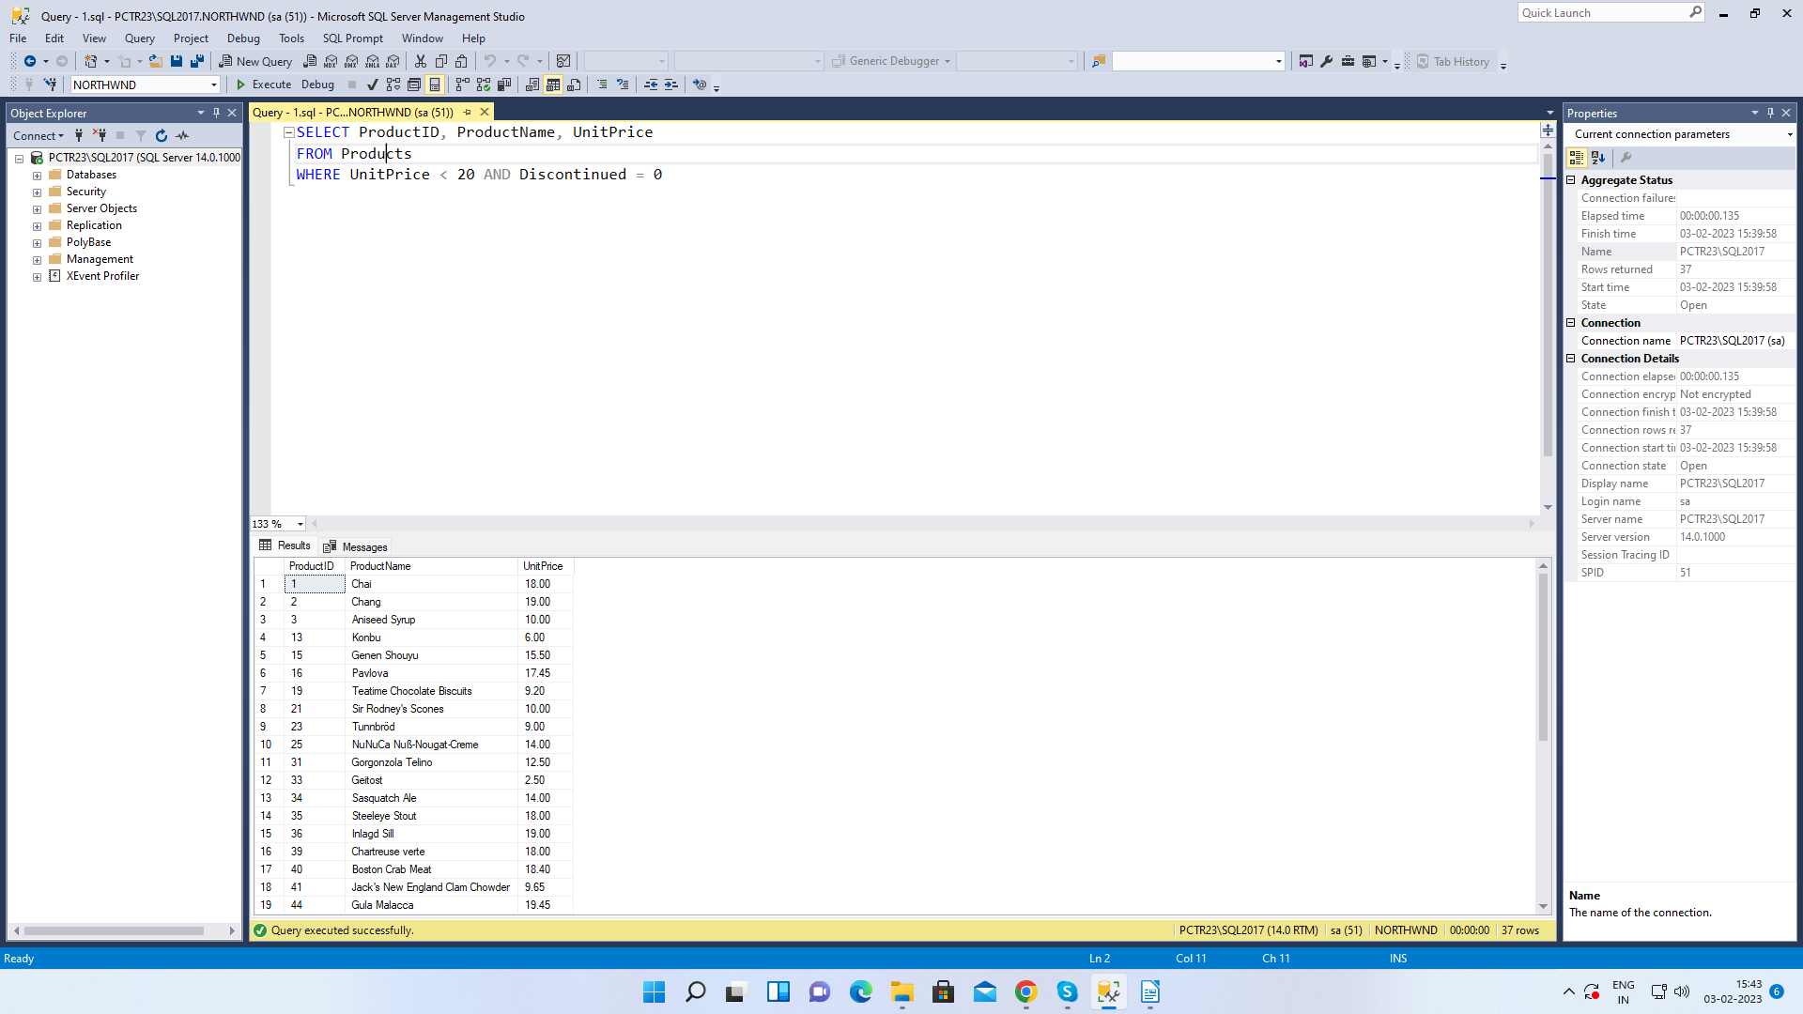

2. Write a query to get Product list (id, name, unit price) where products cost between $15 and $25

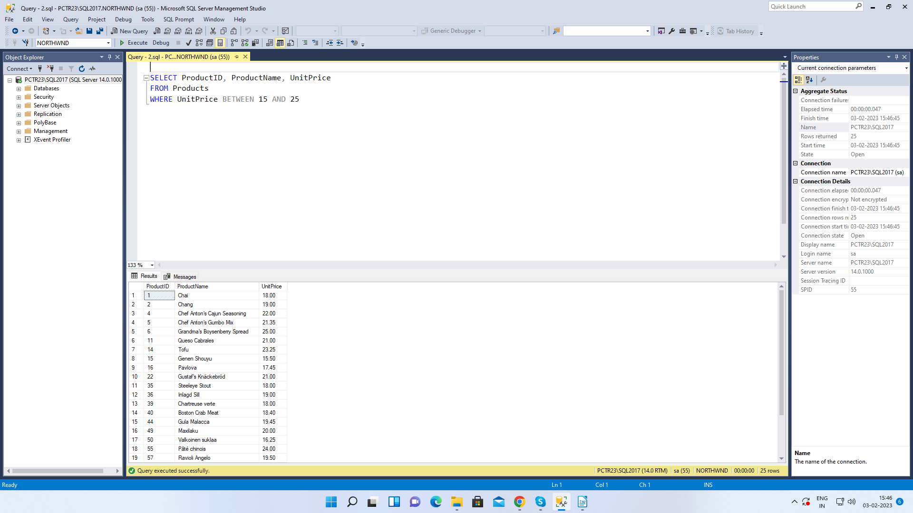

3. Write a query to get Product list (name, unit price) of above average price.

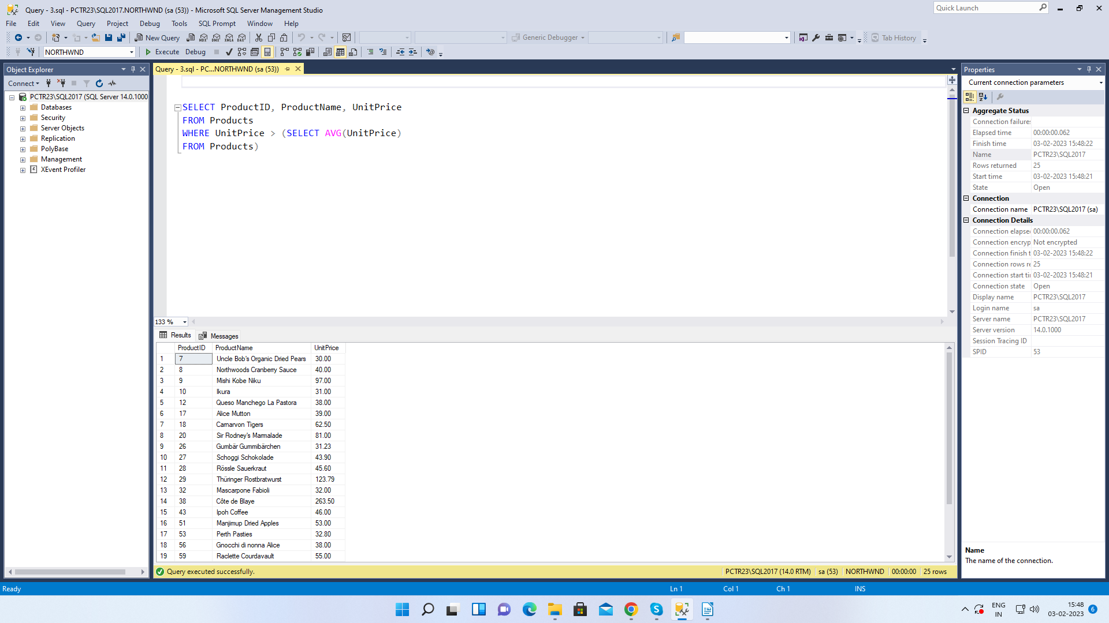

4. Write a query to get Product list (name, unit price) of ten most expensive products.

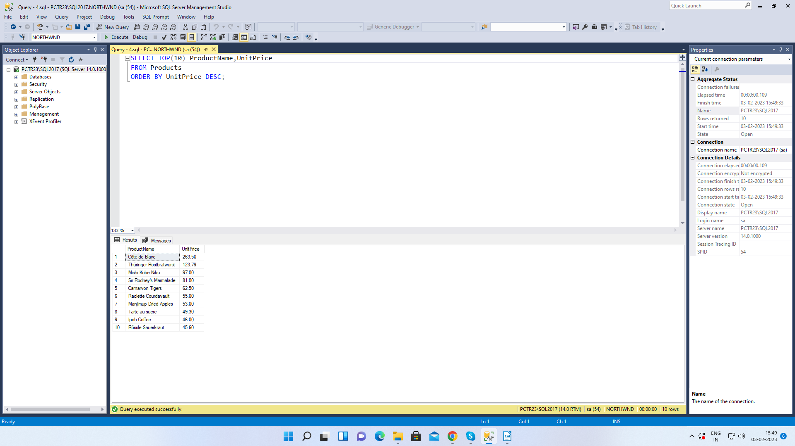

5. Write a query to count current and discontinued products

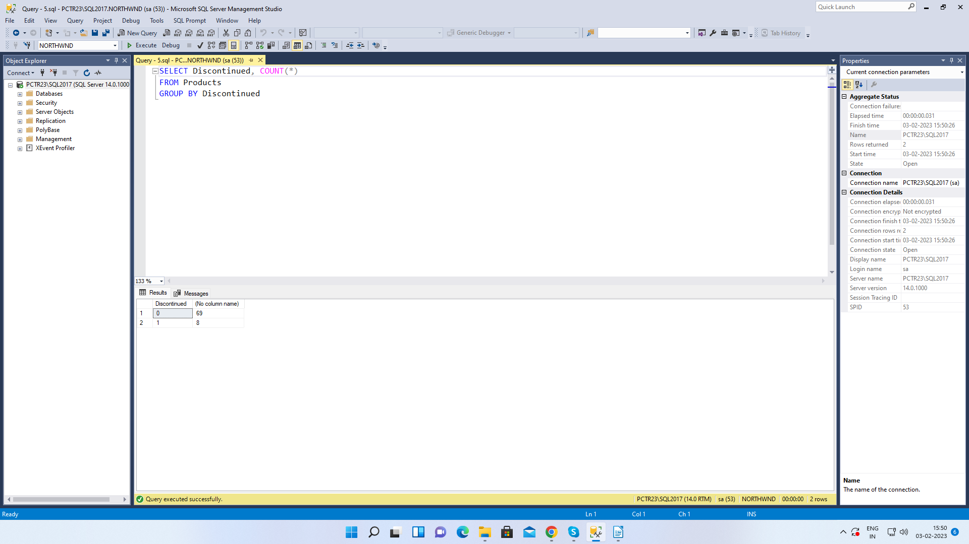

6. Write a query to get Product list (name, units on order, units in stock) of stock is less than the quantity on order

